1. God that created humans
2. God that created elves
3. Elvan ability allowing them to change form
4. Dowrvan creator
5. Gnome creator
6. Elder being of fire
7. Elder being of stone
8. Elder being of wind
9. Desert regions former name

**MMORPG game thing…**

**Core Game**

* Adventure
* Player made classes
* Medieval fantasy
* World wide faction PVP

**Map/World**

* 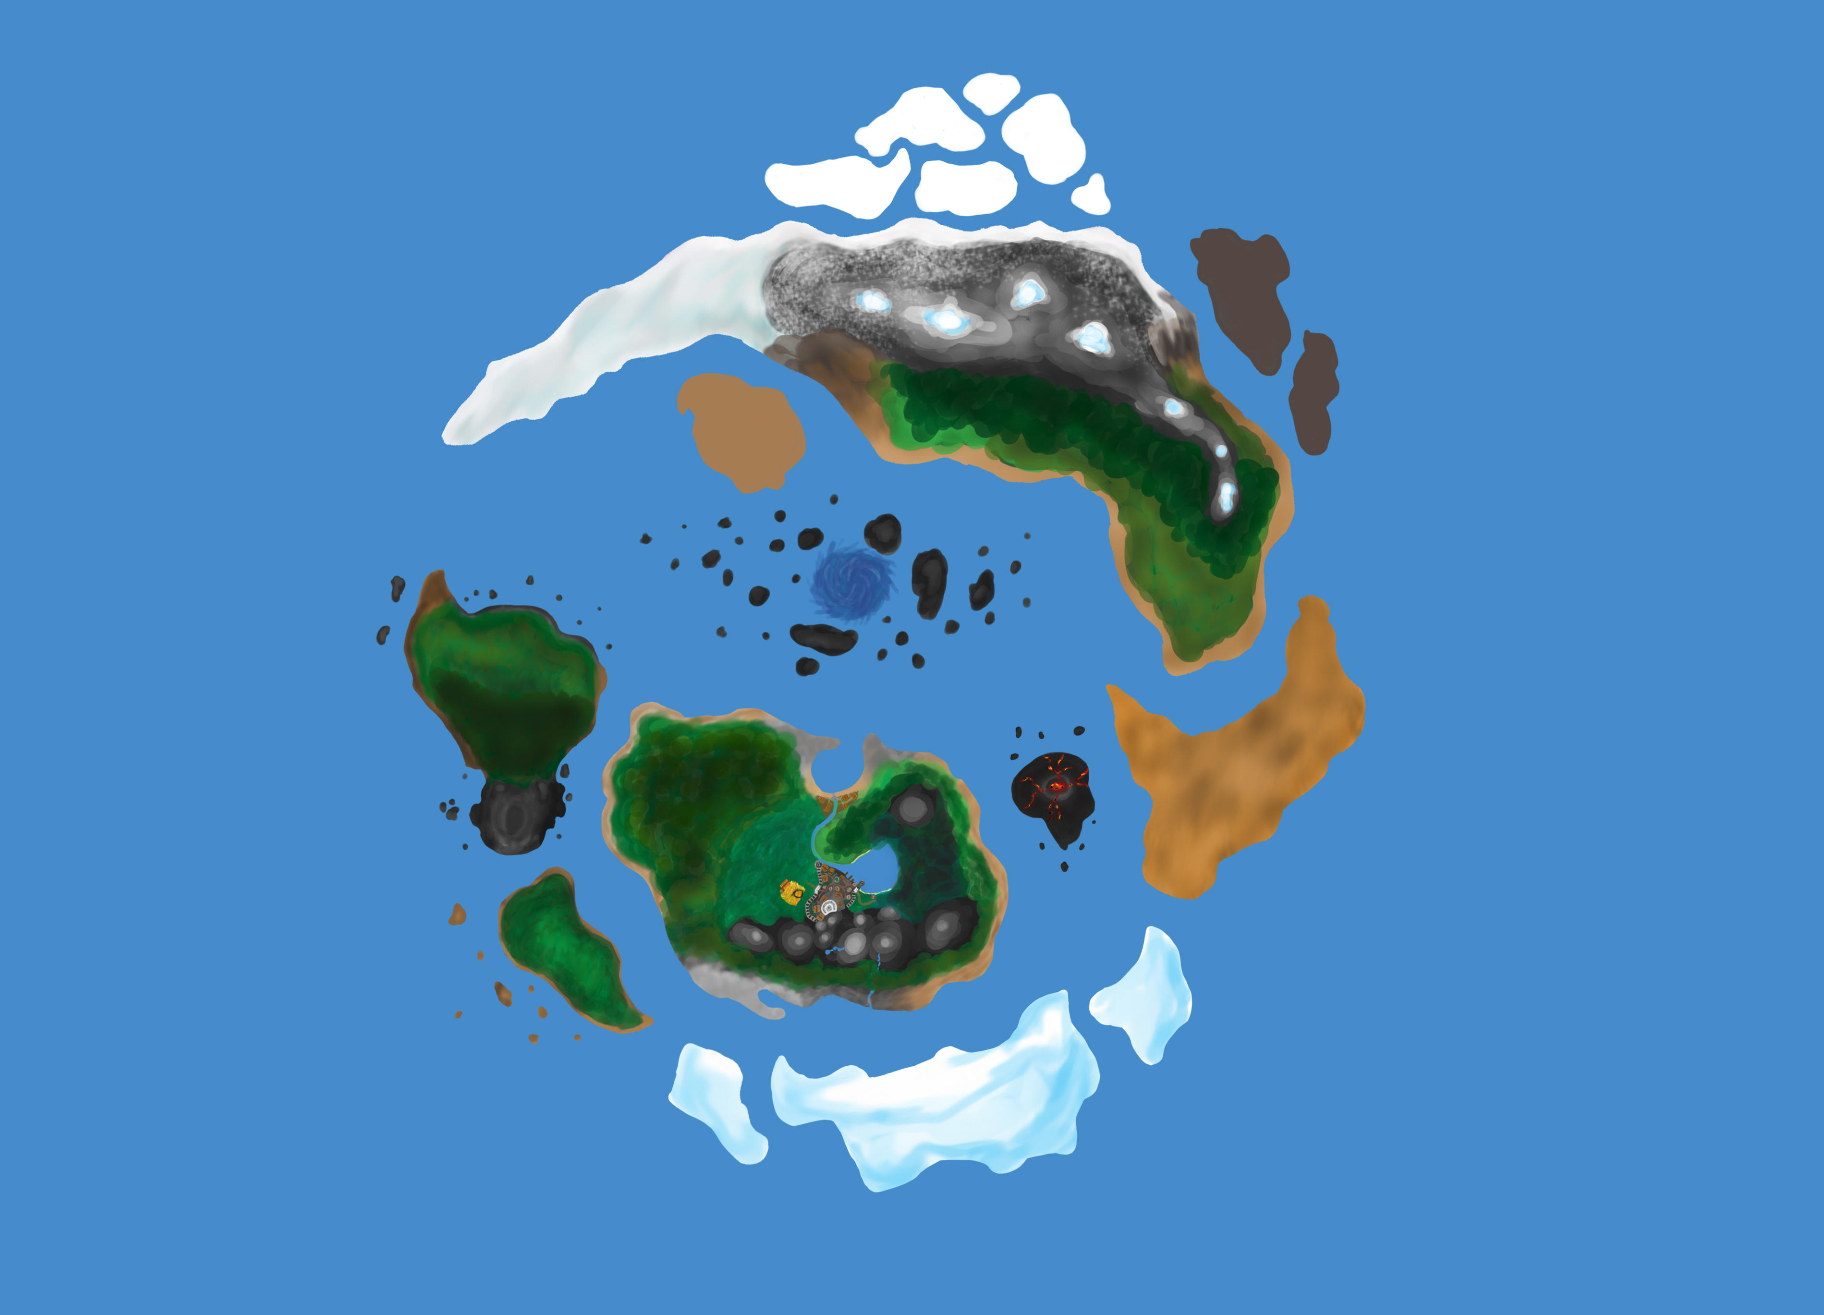Very limited fast travel and teleports to increase exploration.

**Races/classes**

**Human**

Lore:

* Created by the god [1].

Locations:

* Cities of the southern shard.

Traits/abilities:

* Comradery. Passively increases combat stats while in a party.

**Elves**

Lore:

* Created by the god [2].
* Can take on the appearance of the nature around them at will. This will eventually become more permanent as they spend more time in these forms. These transformations give the impression that there are many elven races living around then world, although they are just under the influence of the land they inhabit. Elves can change back to their original state at will.

Locations:

* Forests of the northern shard.

Traits/abilities:

* [3]. Takes on the essence of the nature around them, giving them special elemental powers and abilities.

**Dwarves**

Lore:

* The oldest race.
* Created by [4] to be their servants. They eventually revolted and killed their master with the help of [5]. They now worship [5].
* They attempted to colonize the entire world with their massive navy but were eventually repelled by the humans and forced back to the mountains of the northern shard.
* They are jealous of the gnomes because they were created by [5].

Locations:

* Mountains of the northern shard.

Traits/abilities:

**Gnomes**

Lore:

* Created by [5], they are a peaceful race that was almost driven to extinction when the dwarves attempted to take over the world.
* Now they are scattered around the world in small numbers.

Locations:

* Small villages scattered around the world.

Traits/abilities:

* They are quick and nimble, proficient in stealth.

**Talenguard**

Lore:

* Talenguard were the origin of the notion of angels.
* They are extremely powerful half bird half man race.

Locations:

* Floating islands.

Traits/abilities:

* They poses the ability of flight.

**Tideborne**

Lore:

Locations:

* Underwater cites.

Traits/abilities:

* Can change between land and sea forms.

**Orks**

Lore:

Locations:

* Nomadic tribes, originally from the [9] region now the desert island.

Traits/abilities:

**Combat**

* Not targeted combat, you will have to actually hit the hit boxes to deal damage.
* Movement will be a large part of combat, using rolls, sidesteps and dashes will be very useful.
  + Pvp
  + Armour/wepons
  + Death
  + Damage types

**Leveling/Stats**

*(Level)/(prestige)

Levels 0-9

* + Every time you level up you will increase your stats based on the combat styles and weapons you used during that level.
  + It should take around 3-5 hours (min) to reach level 9 the first time. Increasing as you prestige.
  + At level 9 players should be able to participate in all content. Prestige should not be required although it may be beneficial.
  + At level 9 you can reset to level 0.

Resetting

* + After reaching level 9 you will have the option to reset to level 0, and have all your stats returned to the initial state
  + Resetting will allow players to “rebuild” their character if they want to try a new style.
  + In addition they also be given extra stat points to spend to expand their builds.
  + Every time you reset you will increase in prestige.

Prestige

* + The point of prestiging is to give the lower level content some replay ability without just having maxed players invading lower level players areas to grind for some rare drop.
  + Every prestige rank will allow you to have an extra stat point at level 0.
  + Also the xp curve to level back to 9 will be increased.
  + After you reset to prestige 1 you will be given 1 stat point to put in any stat. after prestige 2 you will get 2…
  + This will allow players to create more interesting builds by allowing them to use more than one weapon/armor style. If they choose to prestige enough.

Stats

* + Stats influence the kinds of weapons/armor that players can use. Content will not be.
  + They only stats points that players will be able to directly choose where they go are those earned through prestige. All other will be given when leveling.
  + Increasing stats will grant more access to the respective stat tree giving new abilities and other unlocks.
  + When an ability is unlocked it will start at 0/100% as players use it, they will level up that ability, 100% is full effectiveness, 50% will half effectiveness and so on. Example, 50% heal will heal half that health of 100% heal.
  + The highest branch of the stat trees will be available at 9/0 if players are able to focus their leveling into a single stat. although after prestigeing they will have more access to other trees.
  + Abilities bay require more than one stat, such as magic/spirit abilities

Stat trees

* Melee
  + Swords and shields
* Ranged
  + Bows and arrows
* Magic
  + Damage spells
* Spirit
  + Summon spirits to assist you
  + Buff/heal
* Nature
  + Identify plants and animals
    - Giving boosts while interacting with them
  + Tame animals
* Elemental
  + Summon storms, earthquakes, and lightning… elemental shit.

**Abilities/moves**

* The core moves and abilities will be on a tree and can be accessed if using the right gear.
* Gear can unlock more than one of these moves as well as restrict them
* Moves: stab, slash, bash, block, heal, snipe, blast, roll, sidestep, dash…
* Example: a spear would have access to stab and restrict roll while a sword might have access to stab and slash.
* All moves will be accessible at level one
* As you increase your stats you will gain access to more unique and refined moves and abilities through trees.
* Rather than just having all abilities on a hot bar you will bind them the two mouse keys, e and q, in addition some moves can be bound to 1, 2, 3 and 4.
* You will not be able to use moves that you don’t have bound to the keys

**Skills/Traits**

* Rather than just grating xp from training the skills, you will progress by becoming proficient at the lower skills of the skill trees
* Example, in order to make a sword you must be proficient at making daggers.
* To become proficient at making thing you will have to successful make X amount of a given item.
* Being proficient at a certain item will cause you to make greater and more powerful versions of that item, as well as being able to repair that item without bring it to a blacksmith.
* Every level you will gain a “skill point” witch will unlock a skill of your choice, after it is unlocked you will be able to train that skill/trait
  + Manufacturing/crafting ()
  + Enchanting (magic)
  + Gathering (nature)
  + Cooking/potion making ()
    - Food
      * Temporarily increase the rate in witch your health naturally heals
      * Temporary buffs
    - Potions
      * Stat boosts
* Skills will not be reset when you prestige

**Lore/Quests**

Creation Era:

* Before time
* Elder Beings
  + [6] (Fire)
    - after the end of the creation Era the Elder of fire fuels the Wind Elders protective shield around the others
    - This is the only current conscious Elder Being
    - Looking into the eye of the sun causes madness
  + Lunus (water)
    - Lunus was the first to discover the star core, the Elder of Stone became jealous and the to immortals began to fight. The quarrel threatened to destroy all of existence until is was suppressed by the Elder of Winds.
    - Before being put to sleep Lunus’s eye was plucked from its socket and now orbits the planet as the moon.
  + [7] (Stone)
    - after succumbing to jealousy of its sister star core it began to fight with its sibling until becoming surrounded by the wind Elder.
    - Unlike the others the Stone Elder had no eye and therefore blind.
    - The socket where its eye would have been housed is now referred to as the pit
    - The Elder Beings claw now forms the highest point on the entire world.
  + [8] (Wind)
    - unlike the other Elder Beings the Elder of Wind doesn’t take a physical form.
    - The Elder of wind surrounded the fighting Stone and Water Elders, signifying the end of the creation age. This cause all three of the Beings to fall into a deep sleep.
    - In order to suppress these two great powers the Elder of Wind requires to be charged by the Elder of Fire.

The Water Elder Lunus and Stone Elder [7] are trapped in an eternal fight over the star core, a powerful artifact of immense power. In order to suppress the destruction the Wind Elder [8] surrounds them. The Fire Elder [6] feeds it with energy in order to maintain balance. Thus creating the word and the sun. The star core is now at the heart of the planet emitting energy through the two Elder Beings.

Life Era:

Through wounds in the now slumbering Elders seeps energy, creating new generation of less powerful immortals. The most powerful of these become known as gods and can create life of their own by manipulating energy wells found around the planet. They then inhabit this newly created world. For millennia they live in peace, until one seeks to take control. There erupts a great war, each side attempting to control the most territory. They create lesser beings to aid them in their conquests. The war concludes with the “shattering” of the main super continent unveiling the pit. The god that initialized the fighting and his fellow conspirators are banished to the pit. Although in order to keep the pit closed they had to exhaust and immense amount of their own power and are forced to go into a perpetual state of hibernation, allowing the newly created mortal races the flourish in the now battle torn lands.

Mortal Era:

* The current Era the game takes place.
* Separated into Ages by the dwarves

Age I (Discovery).

* After the banishment and slumber of the gods the fragmented land was left to the lesser mortal beings.
* Dwarves the oldest of the races, were the first to traverse the entire planet, using their highly advanced ships.
* The Elven clans split up and relocated to separate parts of the globe.
* Gnomes stayed for the most part in their villages of the southern shard.
* The Orks former home was destroyed in the shattering and became the desert island; they now traverse the world as a group of nomadic tribes.
* The Talenguard and Tideborn stay in their territory in the seas and skies, interacting with the other races for trade.
* Humans are still tribal and are for the most part ignored by the other races.

Age II (Settlement).

* The dwarves, with their superior technology begin to establish colonies all over the globe.
* Elves discover the ability to adapt to the land in witch they inhabit and become less involved with the outside world.
* The orks settle in the planes of the southern shard
* Talenguard and Tideborne begin to distance themselves from the rest of the word.
* Humans begin to build cities on the southern shard and advance in culture. They begin to fight with the Orks

Age III (Conquest).

* Dwarves become greedy and attempt to control all other races
* War brakes out but the dwarves with their superior war machines quickly seize power
* Talenguard and Tideborne fully separate themselves form the other races, people begin to believe they never existed
* The dwarves kill and enslave the gnomes
* Elves do not interfere

Age IV (Defeat).

* The Humans and Orks become fed up with their Dwarven overlords; they form a truce and begin to fight back.
* Eventually they enlist the help of the Elves who come out of seclusion to help the all but extinct Gnomes
* The dwarves are spread to thin and are eventually pushed back to the mountains of the southern shard
* The world is divided between the races
  + Humans and Orks split the southern shard
  + Elves remain in there settlements
  + Those gnomes that remain reside in small villages scattered around the remains of the former dwarves empire
  + And the dwarves are restricted to the mountains

Age V (Seclusion).

* Dwarves develop a new government system and elect a new leader, they slowly begin to leave the mountains
* The humans begin to expand their borders, eventually spreading to all corners of the globe
* In order to maintain peace and order they create a governing body consisting of representatives from all races and factions, a leading faction is chosen every year, voted on by the other factions.
* This is maintained until on of the leaders is assassinated during their term. The other factions begin to fight over who will lead them. Eventually it breaks into war
* The governing body is dissolved and all the factions are fighting over land and power

Age VI (Emergence).

* --Game takes place now--
* The dwarves are no longer confined to the mountains and join in with the faction wars
* Humans, Orks, Dwarves and Elves all intermingled in different factions fighting over power.
* Talenguard and Tideborne emerge from their homelands and join in
* Now all factions are at war

**Factions**

Factions:

* Factions are not race locked
* You can join any faction as any character
  + Although some different races will have small dialog changes depending on the faction
* You will not have to choose a faction on creation, you will join the them while you play
* As you progress within a faction you will rise through the ranks
* You may change factions but you will reset your rank and loose all benefits that arte associated with your previous faction
* There will not be much difference in rewords/benefits between the factions to not make deciding what faction to join a choice of what reword you want
* Each faction will have different ideologies and may be allied and enemies with the other factions

**Religions**

**UI/HUD**

* Very minimal UI

**Minigames/events**

* + Water trade routs
  + Property management
  + Tournaments

**Monsters/creatures**

**Armor/ weapons**